EXERCISE 13
- Which command displays the MySQL version?
Answer: SELECT version();
- Use the SELECT command to evaluate 4 X 4 X 4 and name the column Cube of 4.
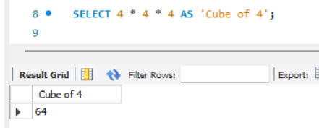

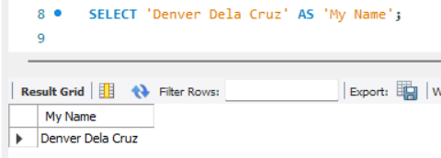
- Display your name with SELECT.

